

**Department Of Computer Science**

**National University Of Computer And Emerging Sciences.**

THE DECORUM

Team Members:

Syed Muhammad Aqeel Abbas

17k-3701

Muneeb Ul Hasan

17k-3717

Muhammad Furqan

17k-3836

Dr. Fahad Samad - Signature

1. **INTRODUCTION:**

E-commerce (electronic commerce) is the ordering and selling of merchandise and services, or the transmitting of funds or data, over an electronic network, primarily the internet. These business transactions occur either as business-to-business ([B2B](https://searchcio.techtarget.com/definition/B2B)), business-to-consumer ([B2C](https://searchcustomerexperience.techtarget.com/definition/B2C)), consumer-to-consumer or consumer-to-business.

Augmented reality (AR) adds digital elements onto a smartphone camera, making an illusion that holographic content is a part of the physical world around you. Augmented reality allows you to virtually try on glasses or see how home objects will look on your table. Such applications must distinguish between the physical and digital world to place virtual objects onto the right area.

* 1. **MOTIVATION:**

Our motivation for this project to enable customers to search, detect and position 3D objects via AR technology in the real environment. This app will address the existing problem by which consumers had to go to showrooms and try to imagine how each product  would fit into their place. However, this our app will allow customers to insert their e-commerce products that looks lifelike into their places before buying the actual furniture.

* 1. **SIGNIGICANCE OF THE PROJECT:**

Purchasing interior design products often has a problem that consumers may not be satisfied with the products they have bought because they cannot arrange them in their own place before buying them. The aim of this project is to develop an android application called 'DECORUM' using Augmented Reality technology for interior decoration that will help customers visualize how furniture and interior design products will look and fit (to scale) in their home and can also provide details of products to support customer decision-making.

* 1. **PROJECT DESCRIPTION:**

In the field of interior designing, the increased augmented reality could not fully take control. Today, people are familiar with the technology and operate smartphones that support AR. Thus, the idea of developing an interior design application leads the designer to be technologically advanced. Moreover, our app ‘DECORUM’ aims to achieve several other objectives which are as follows:

* **Improve customer’s experience in online shopping:** The project aims at providing the use of their smartphones to customers with a realistic picture of the furniture. Therefore, the user can then open the camera on the smartphone to see the selected product in AR from the list. Users can therefore immediately see how well the product is and whether it meets their needs and preferences, without the hassle of going to showrooms or travelling out.
* **Provide the featured product with realistic 3D view:** It is not enough to encourage users to display the products only from an angle so the application should be able to calibrate the 3D model with information provided for correct positioning of the products. Users will also switch around the products to see how it feels from different viewpoints. In addition, anchors should be positioned on the plane surface to the object on which the camera is aimed. This stops the movement of products from shifting with the smartphone thus making it impossible to watch from a certain perspective.
* **Provide the real-world atmosphere with correct live size:** The project must be able to view the items in a live format so that customers can ensure that the product blends into the actual space available. Therefore, having a live scale view helps create a practical environment for customers as if they had bought the items, however it disappears automatically when the application is closed.
* **Allow the application to be easily maintained:** Since the project is used on the online platform, developers need to be able to effectively perform software maintenance. Developers should also be able to add models to the application's database, which should automatically represent the application data retrieval. Therefore, users can instantly view new products and take a look at the product with AR.

1. **METHODOLOGY:**

As our project is linked with another project, the first thing that we will do is that we will make an app which will be fetching data to our app from the database of the other project. Then if the customer searching on the web wants to see the product via AR, there will be an option beside the product on the web, like (“Click to check this product on AR”), then from there our Application will open on customers mobile, app will first ask the customer for permission to open camera, then the customer can check out the product by placing it anywhere he/she likes in his/her room. Customer can also check out the sizes in which that product is available, suppose if the customers selects a vase of medium size than the order of selected size will go towards the web and from there customer can check out.

For a new customer, not coming directly from the Web Button but installing our app directly from Play store. The App will first ask permission of camera and then the app will open. He will see a list of items that our currently available on the web. If he wishes to check out the product, he can click on it and see details or he can check that product in AR and then checkout towards the web to further process the order. There will also be buttons of login and signup which will redirect users towards web and from there they will be able to login or make a new account.

1. **FEATURES:**
   1. **IN SCOPE FEATURES:**

* 3d Object Tracking.
* Able to select angle of product.
* Take pictures while using AR.
* Share pictures.
* Select available color.
* Search items.[FYP2]
* Click on product to see details of it on web(other project) [FYP2]
* Recommendation of products[FYP2]
  1. **NOT IN SCOPE:**
* Product details.
* Add to cart products.
* Signup/Login

1. **PLANNING:**

**Project 1:**

In Project-1 we will be making an application which will only be showing interface of how will app our look after the connectivity of database from the web (other project).App will be asking the permission for camera and we will insert dummy products for FYP-1 to show how users will be able to see products that will be on the web after the connectivity from the database which will be done in FYP-2.

**Project 2:**

In Project-2 we will be connecting our application with the database of web (other project) and then our application will consist of products that are available on the web.

After connecting with the database, we will then integrate AR in our application so that the customers can check the product via AR and be able to make choice by seeing the product by placing it in real life and make online shopping hassle free.

1. **HARDWARE AND SOFTWARE REQUIRMENTS:**
   1. HARDWARE REQUIREMENTS:

Augmented reality requires Android version 7.0.0 so smart phone that will run this app should have android version 7.0.0 or should be upgradeable to 7.0.0

* 1. SOFTWARE REQUIREMENTS:

This app will only work on Android because Seanform api is only for android.

1. **SYSTEM DIAGRAM:**

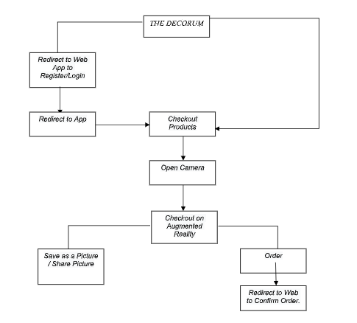

[fig. 1] Work Breakdown Structure of our Application

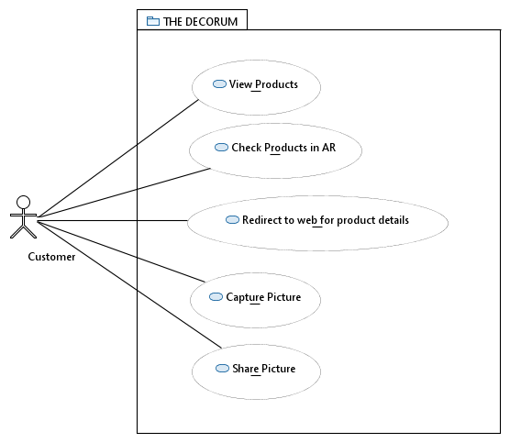

[fig. 2] Use Case Diagram of our App

1. **REFERENCES:**
2. Maxst.com. 2020. [online] Available at: <http://maxst.com/#/en/arguide> [Accessed 16 October 2020].
3. Google Developers. 2020. *Quickstart For Android  |  Arcore  |  Google Developers*. [online] Available at: <https://developers.google.com/ar/develop/java/quickstart> [Accessed 16 October 2020].
4. "Augmented Reality App Development - A Guide To Getting Started". 2020. *Waracle*. <https://waracle.com/blog/augmented-reality/introduction-augmented-reality-app-development/>.
5. "Best AR SDK For Development For Ios And Android". 2020. *Thinkmobiles*. <https://thinkmobiles.com/blog/best-ar-sdk-review/>.
6. "The Rise Of Augmented Reality In Interior Design And Property Development". 2020. *Iflexion*. https://www.iflexion.com/blog/augmented-reality-interior-design.